**SELENIUM**

**OPEN URL USING ALL BROWSERS**

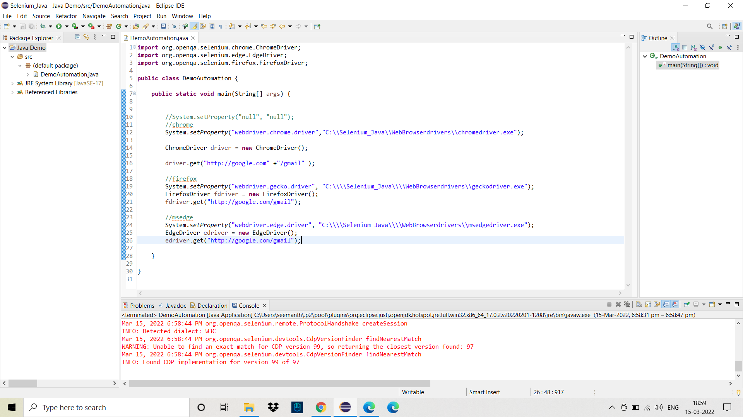

**MAVEN DEPENDANCIES pom.xml:**

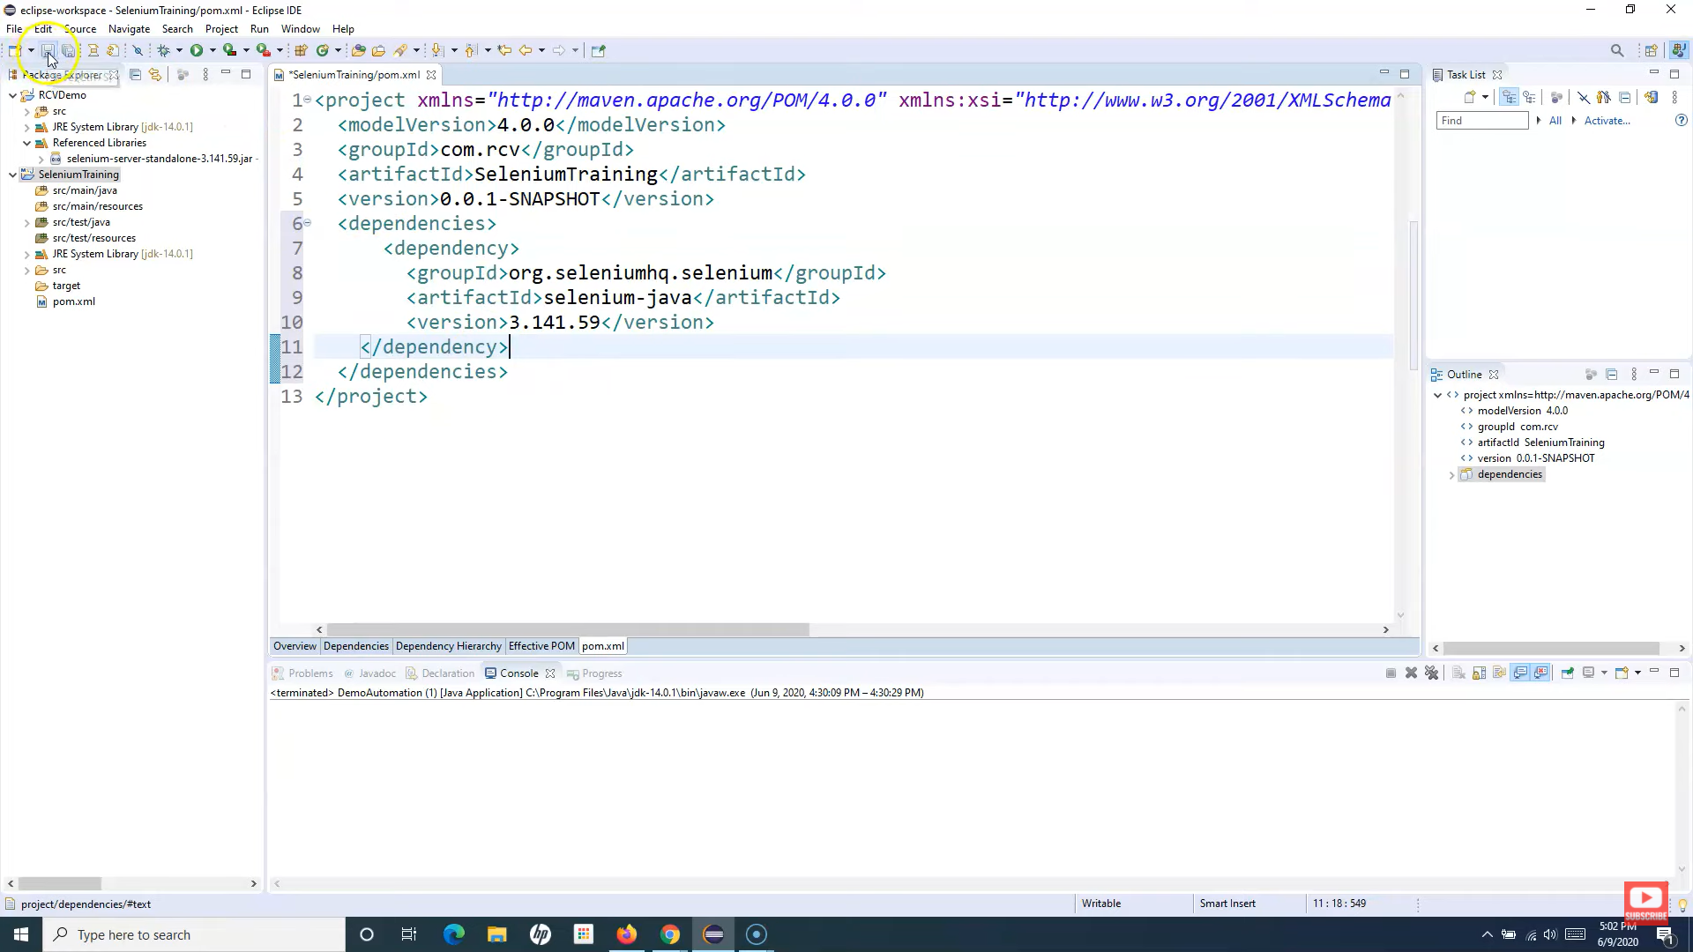

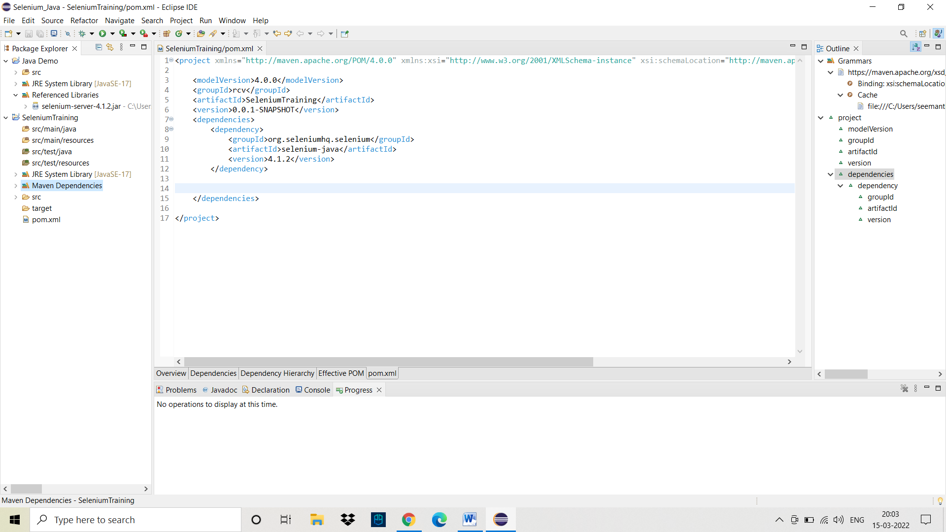

*Maven*

*Dependencies*

**Opens ebay.com-🡪 maximize🡪search mobile🡪exit.**

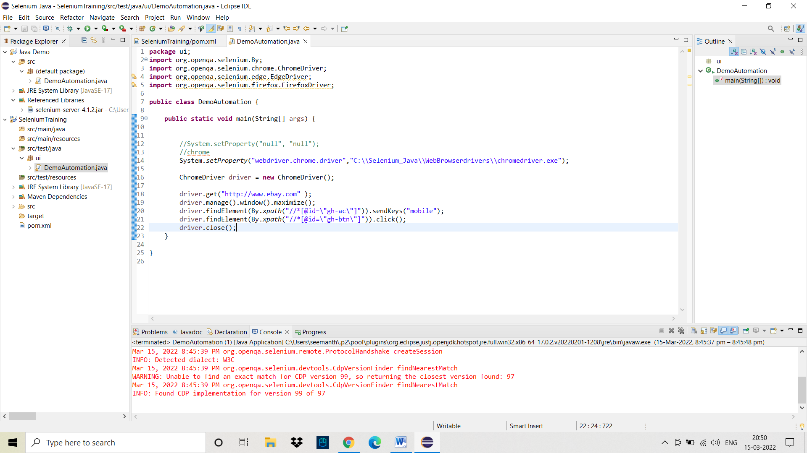

**Using Webdrivermanager method : we don’t need to download drivers of browsers**

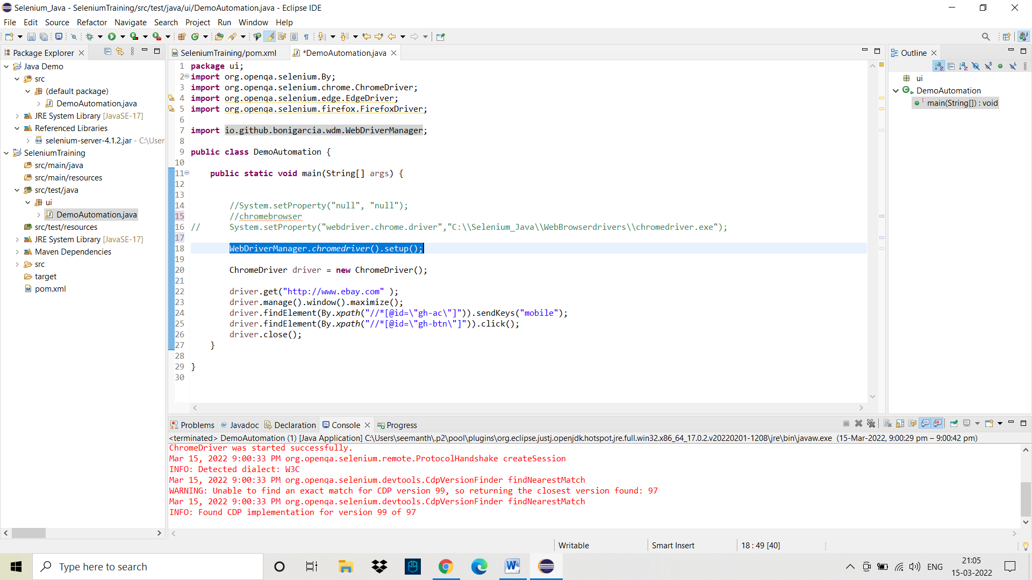

**Enter dependencies in pom.xml file**

**(*webdrivermanager*) ---------------------------🡪** from ***maven repository***

<dependency>

<groupId>io.github.bonigarcia</groupId>

<artifactId>webdrivermanager</artifactId>

<version>5.1.0</version>

<scope>test</scope>

</dependency>

**And remove System.setProperty() method**

Use following code (in place of **System.setProperty()** method ) for respective browsers

WebDriverManager.chromedriver().setup(); -🡪chrome

WebDriverManager.firefoxdriver().setup(); -🡪firefox

WebDriverManager.edgedriver().setup(); 🡪edge

WebDriverManager.operadriver().setup();🡪opera

WebDriverManager.chromiumdriver().setup(); 🡪chromium browser

WebDriverManager.iedriver().setup(); -🡪Internet Explorer

1. **Writing first testcase**

